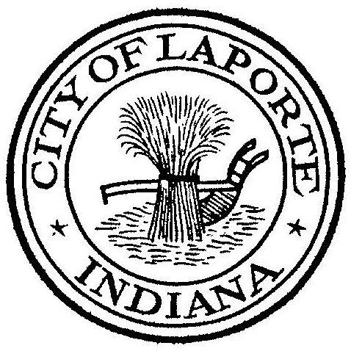
Board of Public Works and Safety
Jessica Romine, Member Tom Dermody, Mayor Mark Kosior, Member
City Hall 801 Michigan Ave., La Porte, IN 46350
Wednesday, July 6, 2022
9:00 AM
AGENDA
- Call To Order
- Pledge Of Allegiance
- Approval Of Minutes
- Public Comment: In Person and via Facebook Live
- Clerk-Treasurer: Claims Approval
Paylocity Agreement
- Department Head Reports
- New Business:
½ Day Fair Day for Employees
-Paul Brettin: Lease Agreement
-Jerry Jackson: Primary Scum Pump Quotes
- Unfinished Business:
- Other Business:
10 Adjourn

